Prayer Relay Guide

Thank you for joining our Prayer Relay this weekend. Our goal is to have unbroken prayer from the time Jesus died on the cross until his resurrection at sunrise on Sunday morning. On the evening before his death, Jesus prays the longest prayer recorded in the New Testament. What makes this the longest prayer is not just the number of words, but the fact that He includes people in the distant future when he prays for “those who will believe in me!” Jesusʼ 1st century prayer included us. He prayed for our unity, joy, protection from evil, and our sanctification, so that through us the lost world would believe in Him. Jesus prays in John 17:20–23

[20] “I do not ask for these only, but also for those who will believe in me through their word, [21] that they may all be one, just as you, Father, are in me, and I in you, that they also may be in us, so that the world may believe that you have sent me. [22] The glory that you have given me I have given to them, that they may be one even as we are one, [23] I in them and you in me, that they may become perfectly one, so that the world may know that you sent me and loved them even as you loved me.” (ESV)

This is the Lord’s prayer for us. That we may be one so that the world may believe. The following guide is a suggestion to assist you in your personal hour of prayer. It is a beautiful thing for the missional community of BCM to pray together! May the Lord make his face shine upon us.

Instructions for Relay:

- Receive a text or phone call from the person ahead of you in the relay. Some hours have two people signed up. So, receive both texts. If you do not receive a text, call the person and check in.
- Pray for an hour in any way you want.
- Write down a sentence or a bullet point of your prayer/adoration/request, include it with the previous person’s prayer point and text the next person (or two people) on the relay.
  - Just something simple like: “Thank you Lord for your work on the cross that saved my soul.” “Lord, make your Name great throughout the Navy.” “Let every room in Bancroft be effected by the Gospel.”
  - If you don’t know the person after you, send a sentence introducing yourself as well.
- Other suggestions: Hydrate with some coffee/tea/water. Change your position or location every 5 minutes with the change of prayer emphasis.

Grateful to God for you!
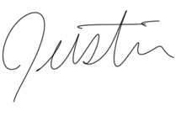
Prayer Circle

In his book, The Hour That Changes the World, Dick Eastman suggests that one divide an hour into 12 periods of 5 minutes each. After 5 minutes you move on to the next form of prayer. The aim of the pattern is to break the hour up into manageable parts, giving both variety and comprehensive coverage to the different aspects of prayer. The original plan was to spend five minutes on each section, but especially in praying for the world, you will find yourself wanting to spend more time on some sections than others.
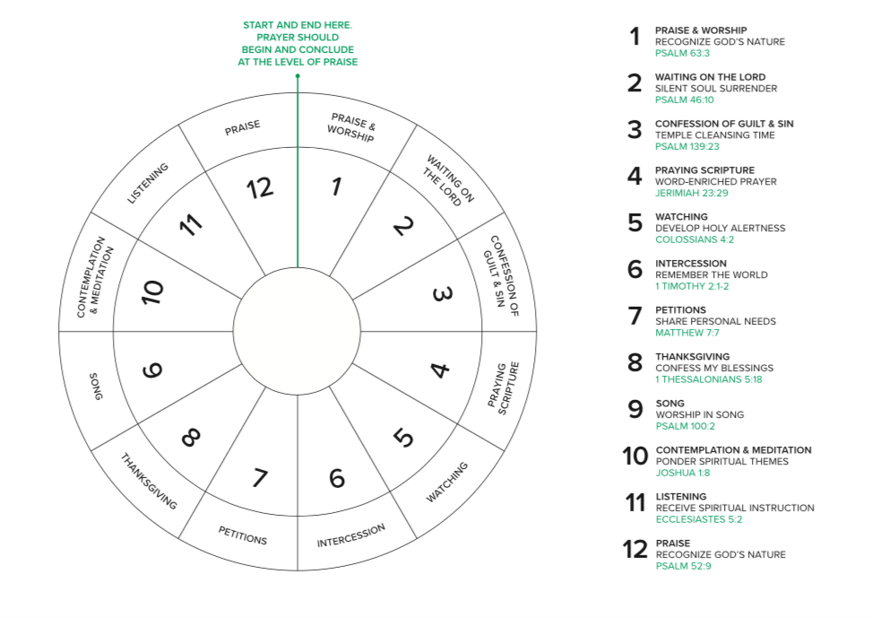

There does seem to be something special about spending an hour in prayer before the Lord. The inspiration of this pattern of prayer is based around the time when Jesus was agonizing in prayer in Gethsemane and found the disciples unable to support him in prayer (Matthew 26:40). When he returned to his disciples and found them sleeping, he asked them: ‘Could you men not keep watch with me for one hour?’

Here is a link to a video with prompts for each section. It may be helpful for you: https://www.youtube.com/watch?v=Z2-xmG1ZfwI&app=desktop
The first section of this prayer hour is praise/adoration. This is a great time to remind ourselves how big our God is, how great is His power, and how amazing is His love and grace. Read selections from Psalm 145 onwards to gain inspiration and content for your declaration. Praise God for His heart and redemptive purpose for the church.

The second section is waiting. Read 2 Corinthians 3:16-18 as encouragement of the promises when we turn our hearts to the Lord. This is a great time to fill our mind with Him, reflecting on His nature, His presence, and His love for us and for the world.

Next is confession. Read Psalm 139:23-24 and Psalm 51, especially verses 10 and 11 dealing with our actions, attitudes, affections and words. Seek personal forgiveness, cleansing and anointing. Read 2 Chronicles 7:13-14 - identifying with the sins of our culture.

The fourth aspect is praying scripture and declaring the promises of the Lord. Read Jeremiah 1:5-12 and 23:29; “‘Is not my word like fire,’ declares the Lord ‘and like a hammer that breaks a rock in pieces?’” Also look at Isaiah 40:8-10; 44:24-26 and 55:10-11. Be open to the Holy Spirit to bring others to mind. You may wish to stand or walk around as you make these declarations. Promises of God’s blessing and God’s justice are equally important to declare.

The fifth aspect is watching - this brings us back to our introductory scripture. Remain alert to spiritual opposition and strengthen yourself with great verses. Read Romans 8:26-27 and 1 Corinthians 14:2, 4, 14 and 15. Be open to pray through those things that come to mind concerning the world. Make a note of things you think may be significant to re-visit in prayer or to share with others.

The sixth aspect is intercession – Read James 5:16-18. It gives us much cause for encouragement. Pray for the lost at the Naval Academy and in the Navy/Marine Corps. Pray for you to have open doors and opportunities to share the gospel (Colossians 4:3 and Revelation 3:7-8); fruit that will remain (John 15:16), and finances for the ministry of your church and BCM (Malachi 3:8-12).

Petition is the seventh aspect of prayer. This is for your own life with the Lord, your ministry, your personal needs, your loved ones and your church, ensuring that your requests are in tune with the Lord’s will. Read 1 Chronicles 4:9-10 and ask the Lord to increase your capacity for prayer and to enlarge your heart for the nation. Bring areas of personal concern before Him and be encouraged by Philippians 4:6.

The next aspect is thanksgiving - for what God has done, and for what He will do for us in response to our prayers. Read Luke 17:11-19. Thanksgiving helps us to focus on God’s faithfulness. Confess all His spiritual, material, physical and external (that is, blessings in other people’s lives) blessings. Be very specific and note that this is an area that should not only be part of a prayer time, but a way of life. If you spend your days in thankfulness you will find the gateway to His presence much easier to enter. Thank the Lord for our communities and for the many ways in which we are blessed. Psalm 103 will also help with this.

The ninth aspect is singing - this is a wonderful gift from God and a key to being filled with the Spirit (Ephesians 5:18-20). Read 2 Chronicles 20, especially verse 22, and Acts 16:16-34. We can sing songs of: praise (Psalm 135:3), power and mercy (Psalm 59:16), thanksgiving (Psalm 147:7), God’s name (Psalm 96:30), God’s word (Psalm 119:54), a new song (Psalm 144:9), and among the nations (Psalm 57:9). Don’t worry about your singing ability, God has an auto-tuner! I’m spending the 5 minutes singing along with Neal Phillips (Song leader at South Shore: https://www.facebook.com/55701425/videos/10106033044003808/

The tenth aspect is meditation. Read Joshua 1:8, noting that the word ‘meditate’ in Hebrew means ‘to mutter upon’. Focus on God himself, on His word, His works, past victories and blessings, and on things positive and good. Read Philippians 4:8.

The second-last aspect is listening - wait for instructions and have a pen ready to write things down. Read John 5:19-20, 30 and Isaiah 50:4-5.

Finish as you started the session by praising the Lord and magnifying Him with confidence that He has heard the prayers for our nation and the world, that the answer is already on the way, and that His power and wisdom are more than equal to every situation. Read Isaiah 65:24.

May your hour bring you much joy in His presence, increased effectiveness in your daily walk, a sense of fulfilment in the part you are playing God’s mission, and some amazing answers to your prayers.

Adapted from “The House That Changes the World” by Dick Eastman, Baker 1978

